Bridgemate II duplicate RF number – How to fix

This documentation describes how a Bridgemate II with a duplicated RF number can be updated and assigned a new unique RF number. Please read these instructions very carefully. Incorrect usage of this update tool may result in incorrect RF numbers which may impact the performance of your Bridgemate II scoring system or result i

Download the file
A unique update tool has been created for your club. Use only this tool and do not distribute or use this tool outside your club. Copy the file to a location on your computer where you have full read/write rights. For example, the “Documents” folder or the “Downloads” folder. Do not move it to a Windows system folder or the Program files folder.

Find the Bridgemates that need to be updated
Collect all the Bridgemates that have RF number 12507538. To retrieve the RF number, press SETUP on the home screen, then INFO, then followed by keeping the ‘5’ key pressed for a few seconds. The RF number will now appear. If the number is different from 12507538, then put this Bridgemate aside and no update is needed for this Bridgemate.
IMPORTANT:
The Bridgemate must contain firmware version 2.2.2 and must be in ENGLISH language. If this is not the case, you must first update the firmware to version 2.2.2 English. See http://support.bridgemate.com/customer/en/portal/articles/2361327-bridgemate-ii-v2-2-2-server-v2-2-1d-firmware- on the Bridgemate Support Center (http://support.bridgemate.com) for more information how to update the Bridgemate.

Connect the server
Connect the Bridgemate II server to your computer and make sure the green light of “USB/battery power” is on. Make sure Bridgemate Control Software is NOT running.

Start the update tool
Double-click on the tool you have been provided to start the tool. The tool tells you for which club the tool has been generated. Please verify that this is your club.
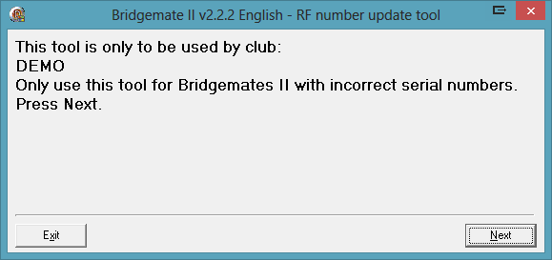

Proceed by pressing Next. After the server has been detected, the Bridgemates can be updated.

Updating the RF number
IMPORTANT: The Bridgemates must be updated ONE AT A TIME. Unlike the general firmware update, you cannot update them all at once.
Press Next on the tool until you see this screen:
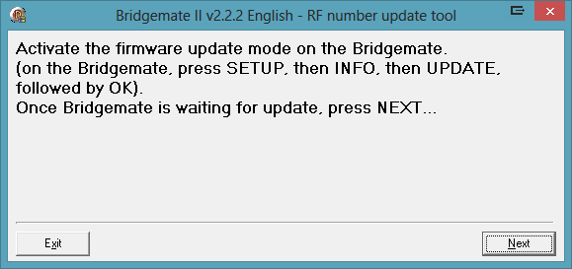
Take a Bridgemate with the incorrect RF number, activate the firmware update mode on the Bridgemate, by pressing SETUP on the home screen, then INFO, then UPDATE, followed by pressing the OK key. Verify the Bridgemate is now showing “Waiting for update…”.
Press Next in the tool. You will now see this screen:
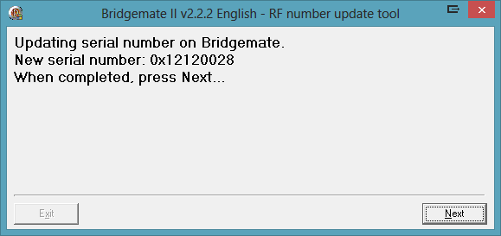
(the new RF serial number will be different)
The Bridgemate is now being updated with the new RF number that is shown on the screen. This process takes only 3 to 4 seconds. Once the update is completed, the Bridgemate will return to the home screen.

Verify the new RF number
Press again SETUP, then INFO, then ‘5’ key for a few seconds to verify the incorrect 12507538 number has been replaced by a new, unique number.

Continue with other Bridgemates
Press Next on the tool to continue the update for other Bridgemates.
REMEMBER: You must activate the firmware update mode only at one Bridgemate at a time! Do NOT update multiple Bridgemates at once!

